SCHOOL OF COMPUTER SCIENCE AND ARTIFICIAL INTELLIGENCE |  |  |  |  | DEPARTMENT OF COMPUTER SCIENCE ENGINEERING
Program Name: B. Tech |  |  |  | Assignment Type: Lab |  |  | Academic Year:2025-2026
Course Coordinator Name |  |  |  | Dr. Rishabh Mittal
Instructor(s) Name |  |  |  | Mr. S Naresh Kumar  Ms. B. Swathi  Dr. Sasanko Shekhar Gantayat  Mr. Md Sallauddin  Dr. Mathivanan  Mr. Y Srikanth  Ms. N Shilpa  Dr. Rishabh Mittal (Coordinator)  Dr. R. Prashant Kumar  Mr. Ankushavali MD  Mr. B Viswanath  Ms. Sujitha Reddy  Ms. A. Anitha  Ms. M.Madhuri  Ms. Katherashala Swetha  Ms. Velpula sumalatha  Mr. Bingi Raju
CourseCode |  |  | 23CS002PC304 | Course Title |  | AI Assisted Coding
Year/Sem |  |  | III/II | Regulation |  | R23
Date and Day  of Assignment |  |  | Week9 – Wednesday | Time(s) |  | 23CSBTB01 To 23CSBTB52
Duration |  |  | 2 Hours | Applicable to  Batches |  | All batches
Assignment Number:17.3(Present assignment number)/24(Total number of assignments)
 | Q.No. | Question |  |  |  |  |  | Expected Time  to complete
 | 1 | Lab 17 – AI for Data Processing: Data Cleaning and Preprocessing Scripts  Lab Objectives:  - Learn how to clean raw datasets using AI-assisted Python scripting.  - Apply preprocessing techniques such as handling missing values, encoding categorical data, and normalization.  - Automate repetitive data-cleaning tasks with AI-generated code.  - Understand how preprocessing impacts model performance.  Task 1 Employee Dataset Cleaning  Task:  Use AI assistance to clean an employee information dataset.  Instructions:  - Handle missing values in salary, designation, and experience  - Remove duplicate employee IDs  - Standardize text values (job titles in lowercase)  - Encode categorical features (designation, employment_type)  Expected Output:  A clean dataset suitable for HR analytics and prediction tasks.  Prompt:- 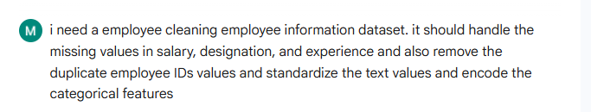  Code:- 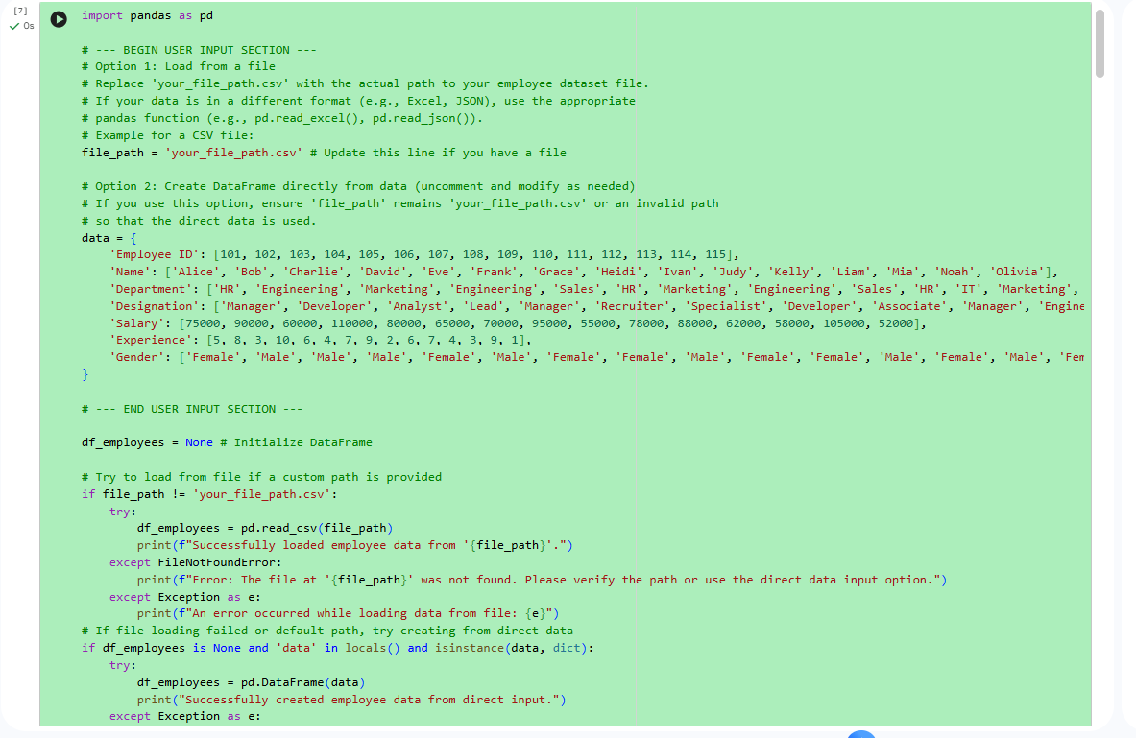  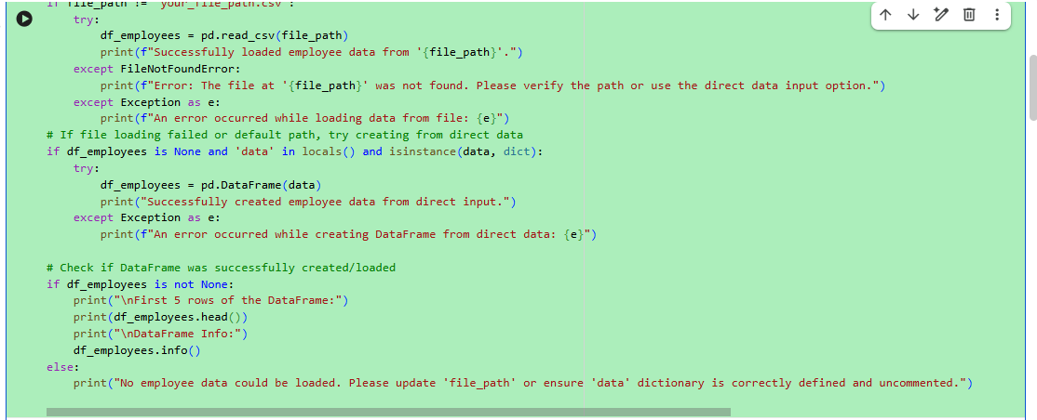  Output:-  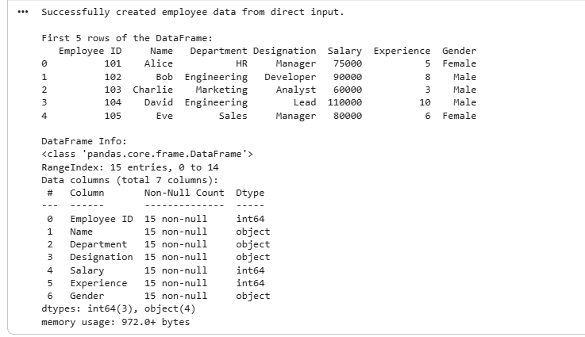  Explanation:-  The employee dataset is cleaned by handling missing values in salary, designation, and experience using suitable methods. Duplicate employee IDs are removed to maintain unique records. Job titles are standardized by converting them into lowercase for consistency. Categorical features like designation and employment type are encoded into numerical values. After these steps, the dataset becomes clean and ready for HR analysis and prediction tasks.  Task 2 – Student Performance Data Preprocessing  Task:  Preprocess student performance data using AI assistance.  Instructions:  - Convert exam_date column into datetime format  - Extract new features (month, semester, day)  - Normalize total_marks  - Detect and handle outliers in marks using IQR or Z-score  Expected Output:  A transformed dataset with time-based academic features and normalized marks.  Prompt: -  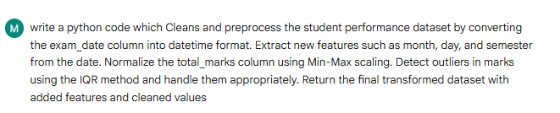  Code:-  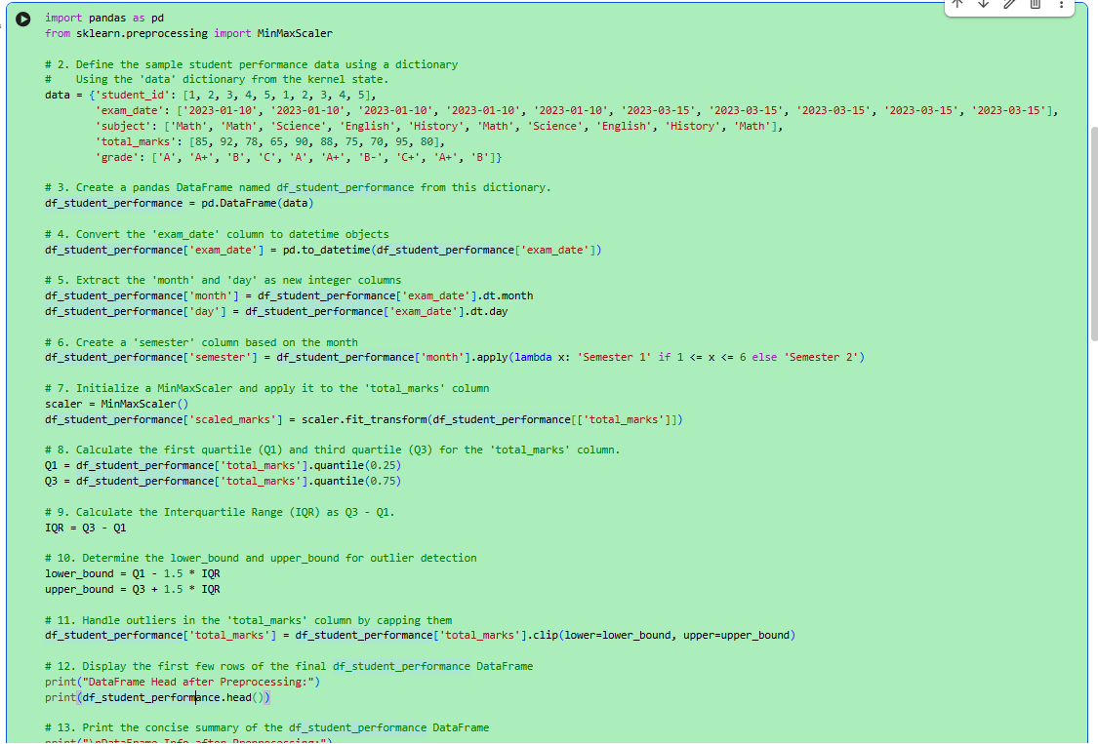  Output:-  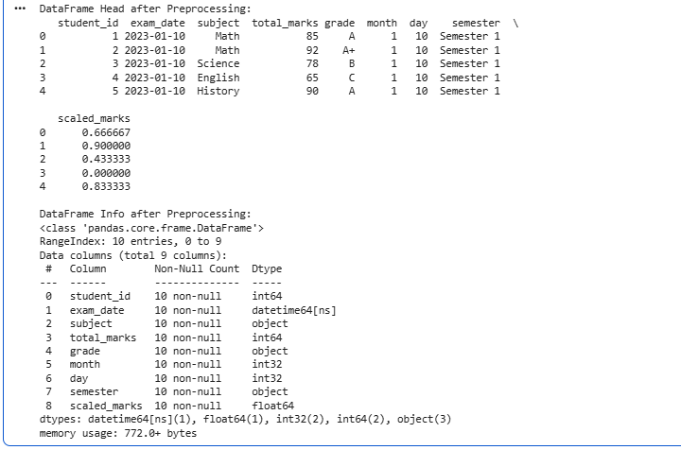  Explanation:-  In this task, the student performance data is cleaned and transformed to make it more useful for analysis. The exam date  column is converted into datetime format so that additional features like month, day, and semester can be extracted. The total marks are normalized using Min-Max scaling to bring all values into a common range. Outliers in marks are detected using the IQR method and handled to improve data quality. The final dataset becomes structured, consistent, and ready for further analysis.  Task 3 – Student Health Data Preparation  Task:  Clean and preprocess student health records using AI scripts.  Instructions:  - Handle missing values in height, weight, BMI  - Encode categorical features (medical_condition, fitness_status)  - Scale numerical features using standard scaling  - Split dataset into training and testing sets  Expected Output:  A preprocessed dataset ready for predictive health analysis.  Prompt:-  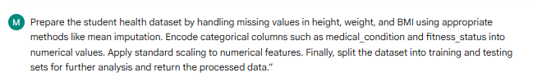  Code:-  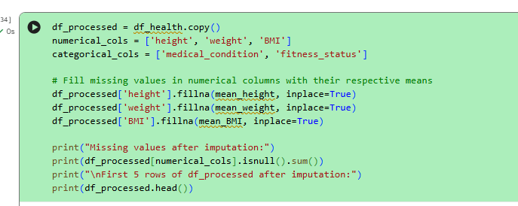  Output:-  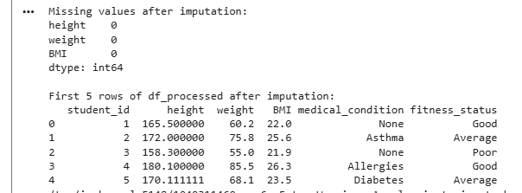  Explanation:-  In this task, the student health dataset is prepared by handling missing values in numerical columns like height, weight, and BMI using mean imputation. Categorical features such as medical_condition and fitness_status are converted into numerical form using encoding techniques. Numerical features are then standardized to ensure uniform scaling. Finally, the dataset is split into training and testing sets, making it suitable for building and evaluating predictive health models.  Task 4: Real-Time Application: Ride-Sharing Data Cleaning  Scenario:  A ride-sharing company has trip data with errors.  Requirements:  - Standardize pickup and drop locations  - Fill missing fare amounts with median values  - Remove duplicate ride entries  - Normalize driver ratings  - Generate a summary of data improvements  Expected Output:  A clean dataset ready for operational analysis.  Prompt:;-  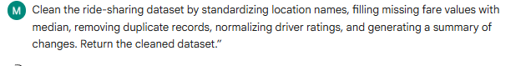  Code and output:-  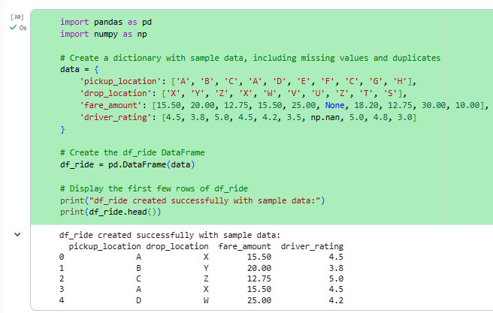  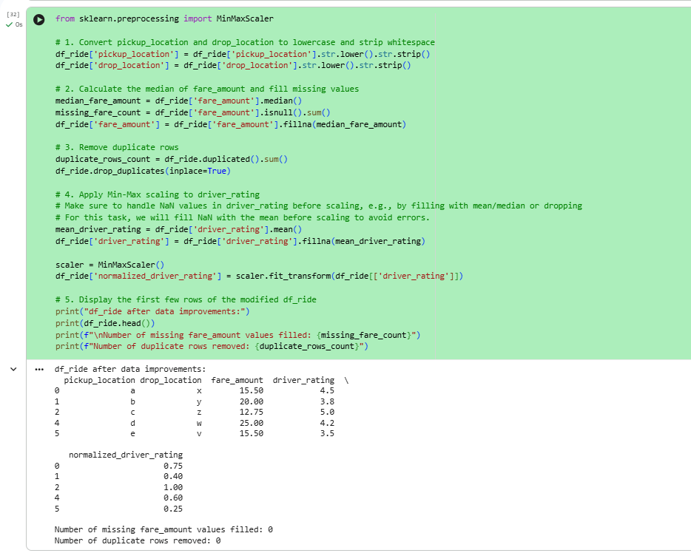  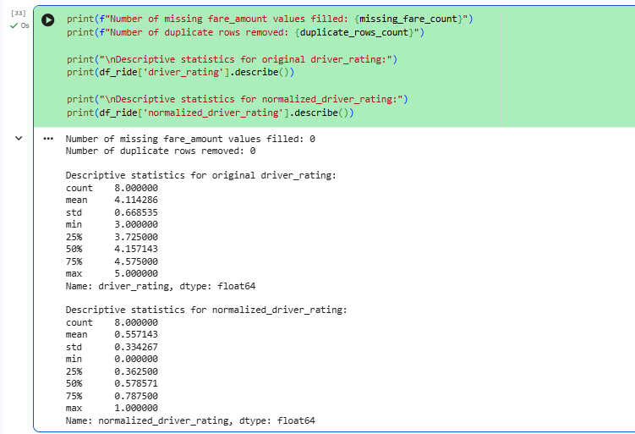  Explanation:-  In this task, the ride-sharing dataset is cleaned to remove inconsistencies and errors. Location names are standardized to maintain uniformity across the dataset. Missing fare values are filled using the median to avoid distortion from extreme values. Duplicate ride entries are removed to ensure data accuracy. Driver ratings are normalized to a consistent scale. A summary of all cleaning steps is generated, and the final dataset becomes clean, reliable, and ready for operational analysis.  Note: Report should be submitted as a word document for all tasks in a single document with prompts, comments & code explanation, and output and if required, screenshots. |  |  |  |  |  | Week9 - Wednesday

